10.17: See Example 10.4. In this case, the moment of inertia I is unknown, so 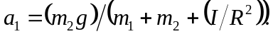 a) 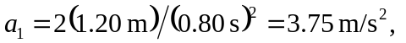
b) The torque on the pulley is 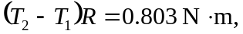and the angular acceleration is

